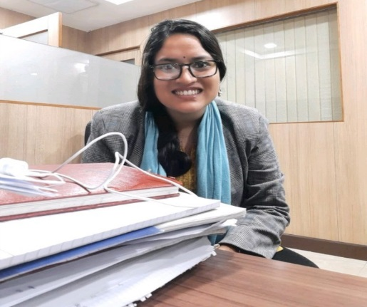

**TRAINING AND PROJECTS**

STRUCTURAL ENGINEER **ESTEEM PROJECTS PVT LTD | 6 MONTHS**

Modeling and dynamic analysis of Fired heater and its components using IS 800 and API 560.

GEOTECHNICAL ENGINEER **EXPLORE ENGG CON PVT LTD |4 MONTHS**

Bore log preparations, sieve analysis and report preparation of Highways, sewer lines and Building projects axial load capacity and Lateral load capacity of Pile Foundation. Liquefaction Calculation

ASSISTANT PROFESSOR **GL BAJAJ INSTITUTE| 7 MONTHS**

Lectures on Concrete Technology, Structural Health Monitoring and environmental engineering subjects. NBA work

GEOTECHNICAL ENGINEER **GEOCONINFRA PVT LTD | 6 MONTHS**

Bearing capacity, settlement and liquefaction calculations of RE wall. Ground improvement technique calculation and RE wall design calculation according to codal provision

GEOTECHNICAL ENGINEER **ICT PVT LTD | 7 MONTHS**

Comments on RE wall design and drawing, RS Wall design and drawing Comments on Gabion wall design and drawing, Rock fall protection works Comments on Geotechnical Report

Shallow foundation design and pile foundation calculations as per site conditions and codal provisions. Liquefaction calculations

ARCHANA RAWAT

* Alaknanda Hydro Power Project Dam site visit.
* Multi-storeyed building design in ETABS training in CSi Delhi, Design and analysis of G+2 building in CPWD
* Soil-Structure Interaction Project in Abaqus.
* FDP on Urban Infrastructure and Tunnel site visit
* GIAN Prog on Geosynthetics and Geotech Structures.

HOBBIES: TRAVEL |SPORTS|READING PHOTOGRAPHY|DANCE

REFERENCES

DTU| PROFESSOR

DTU | PROFESSOR

COLONEL KC TIWARI

DR. ASHUTOSH TRIVEDI

https://www.linkedin.com/in/archana-rawat-111868167/

XTH 2008 PERCENT 93.6%

XIITH 2010 PERCENT 91.8%

KENDRIYA VIDYALAYA CHD

PU-CCET 2010-2014

BE CIVIL (8.5 CGPA)

Seeking a position of **GEOTECHNICAL ENGINEER** to work in a fast-paced and challenging environment where solid analytical and quantitative skills accompanied with a strong passion for industry can be put to use for the success of the organization

**CONTACT INFO**

Phone

+91 9971097330

Email

rawat.1111archana@gmail.com

Web

**EDUCATION**

DTU 2014-2016

MTech Geotechnical (8.1CGPA)

**SOFTWARE SKILLS**

MICROSOFT OFFICE

ABAQUS

ETABS

STAAD.PRO

**WORK EXPERENCES**

GEOTECHNICAL ENGINEER