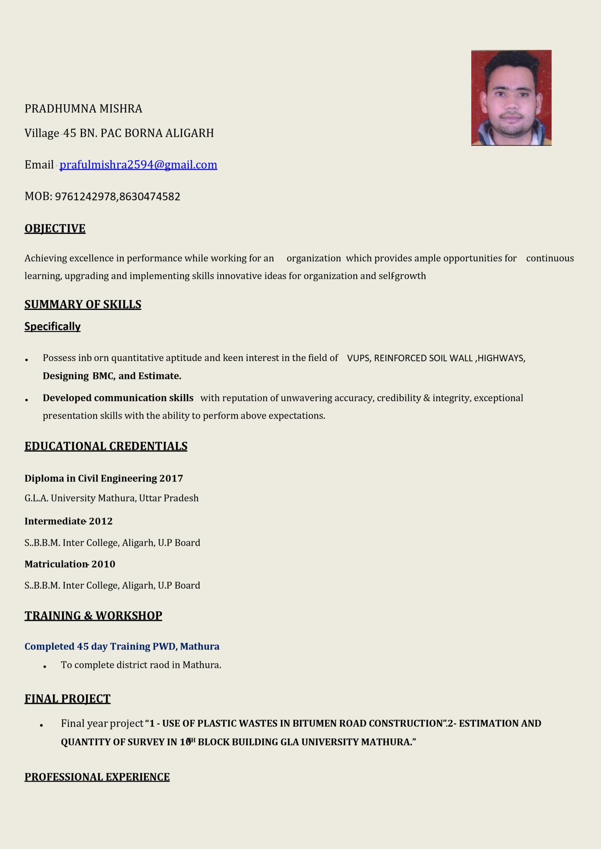

1.sonu infratech ltd Gujrat(2018-2020)

Designation-junior site engineer
- Working in J-3 project of reliance refinery in Jamnagar Gujrat.
JOB RESPONSIBILITIES –
- work with SWP fully check the permit and reading TBT and guide to the
labour.
- Communicate with RELIANCE REPRESENTATIVE And taking all job
responsibility.
- Doing work with in quality and also in safety and also taking award for safety and quality.
2.Strata geosystem Pvt ltd Mumbai(2020-2025)
Designation- trainee Site engineer

JOB RESPONSIBILITIES
- Maintain the all necessary records and documentation.
- Making VUP,ROB,LVUP,FOB,MNB, with reinforced soil wall ,highways, in
different projects .
- 1:-Designation- junior site engineer
- Key responsibilities:-
.Mallavaram to chittoor NH 144 total design km60.00km state of Andhra Pradesh Handling the client /EPC CONTRACOR KNR CONS. LTD ..
2:-Designation -site engineer
Key responsibilities:-

- Thirchy to kallgam total design km 38.700 state of Tamil Nadu Handling the client /EPC CONTRACOR KNR CONS. LTD
  - Handling 2+ more sites with casting plant.
  - Here I have done MNB,VUP,LVUP,Wings wall,with block fascia.
  - So much ground improvement in this project,.
3:-Designation-site engineer
Key responsibilities:-
.chitorgarh to Udaipur NH 27 state of Rajasthan client Hg INFRA.
LTD.
- Many RE WALL is completed in these projects like 7+520(VUP) ,27+500,13+200,40,+103,25+650,56+550,13+110,0+00(closing wall F.O.B),19+220,17+304 etc.

4:-Designation-site engineer
Key responsibilities:-
.NH166 Watambare to mangalweda client GR infra Ltd.
A)in this project so much difficult situation from nature so much rain .
- Responsibilities same but situation different.
Designation- site engineer
Key responsibilities:-
NH-363-Mancherial to repallewada client Adani road transport Ltd.
A)So much documentation work so much work pressure.
B)work with total safety and every Friday give T.B.T to labour.
- Handling 2+more sites comes in 10km stretch work with panel fascia.
- it’s new design of my company in .so much stages learning something new .
6.Desigination -site engineer
Key responsibilities-
.NH45A-Four laning poondiyankuppam to sattanathapuram section client oriental structure engineers pvt Ltd.
It’s new project I am come with some staff setup the first casting yard.
Started the excavation for ground improvement because there have so much black cotton soil .
Handling responsibilities so much , client ,all over running sites , Casting yards
6.Desigination-senior engineer
- Project$-ganga exp project merrut to praygraj (ch 289 to ch 445)
- Client: EPC Adani road transport ltd.
- SUB EPC:Patel infra ltd (ch 289 to ch 445)
- 1.self handed project lead,excution lead over all project.
- 2 Attends the meeting With client and take required decision
SUB EPC ITD CEMENTATION LTD.(ch 445 to 578)
- Starting from over the work started rapidly with sufficient manpower equipment, machinery, Designs,Drawings soil investigate, because of lot of pressure to complete the work on given time.
7.
- Desigination-Project engineer
- Project- Chennai Pheriperal Ring Road.
- Client-Tamilnadu Road infra corporation Limited.
EPC - oriental structure engineers pvt ltd

Now I am currently working in oriental structure engineers pvt ltd.
• Total experience
•I have 6year experience in highways and RE walls in both panel and concrete block fascia .

SOFTWARE PROFICIENCY
- ARC GIS Global Mapper, QGIS, AutoCAD (Civil)
- MSOffice, Excel,word… STRENGHT
- Confidence & positive attitude.
- Good Communication presentation skills to convince/satisfy customer precisely and
clearly.
- Good problem solving and analytic ability skills to resolve the problem in targeted
time.
- Good team player and have excellent interaction skills to coordinate and work with in team.
- Positive attitude to lead a team & to become a team leader.
- Carry a good pleasing personality to handle tough projects & hard conditions

HOBBIES
- Reading books and keeping technical updates.
- Listening to Music.(classical)
- Travelling
PERSONAL PROFILE
Father name: - |  | Santosh Kumar Mishra
Mother name: - |  | Sima Mishra
Nationality: - |  | Indian
Marital status: - |  | Unmarried
Date of Birth: - |  | 15/01/1997
Language known: - Hindi & English
Permanent Add. : - Village – 45 BN PAC BORNA, ALIGARH (Uttar Pradesh)

DECLARATION
I hereby declare that the above-mentioned information is correct up to my knowledge and I bear the responsibility for the correctness of the above-mentioned particulars

• (PRADHUMNA MISHRA)

