CURRICULUM–VITAE

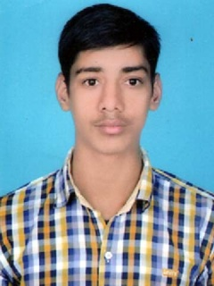

MOHITKUMAR

Address:Vill.Bisera

Dist.Agra(U.P.)–283102

Mob:8239634292,8619794569

EmailId:-mohitkumarchahar1@gmail.com

CarrerObjective:

I am motivated,result oriented confident person.I firmly believe failure is the first step to“success”Positive attitude and will ingness to learn is strong attitude.I am firm & strong to achieve my Goals.My emotion does not come in way of my duties and responsibilities.

Academia:

Diploma in Civil Engineering from BTER,Jodhpur.(2015)with A garde marking

Intermediate passed from U.P.Board in 2012 A garde marking.

High School passed from U.P.Board in 2010 A garde marking.

Professional Profile:

24 daysTraining in HighTechnology Solutionin Gurgaon

Having 3 months experiencein ADITYA BIRLA CEMENT,GOTAN (JODHPUR )

EMPLOYMENT RECORD -:

From Aug 2021 to March 2022-:

Employer : NKC Project Pvt.Ltd.

Position Held : Highway Engineer
Description of duties : Highway construction from OGL to WMM.

From Oct 2017 to July 2021:-

Employer : PNC Infratech ltd.

Position Held : Junior Engineer(Highway)

Description of duties : Highway construction from OGL to WMM & Work of Reinforced Earth wall from (Levelling Pad to top Panel Coping beam).

Project : Six Laning of Chitradurga–Davangere(72km)

COP :1586Crores

Activities Performed:

OGLPREPARARTION

SUBGRADE

GSB

WMM

RE PANEL CASTING WORK AS PER BBS & DESIGN

PCC FOR LEVELLING PAD

TOP PANEL COPING BEAM

CRASS BARRIER ERRECTION

Computer :

Basic,Microsoftexcel,Auto Cad

PersonalProfile :

Father’s Name : Mr.JagveerSingh

Date of Birth : 10Aug.1996

Marital Status : Unmarried

Sex : Male

Nationality : Indian

Language Known : Hindi,English

Hobbies : Listening music & play cricket.

Declaration :

I here by declare that the above mentioned details are true to the best of my knowledge and belief.

Place : Agra

Date :

MOHIT KUMAR

