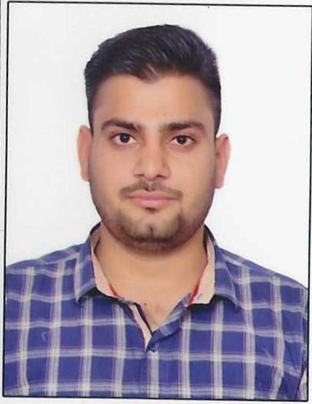 | CANDIDATE FULL NAMEL SUMIT KUMAR | Contact No.9289875166
 |  | Email Id: kumarsumitt4@gmail.com
 | Diploma Specialization: Civil Engineering
 | College Name: Pusa Institute of Technology

Academic Profile
Category | Year Passing | Institute name | Percentage Marks
Class X | 2019 | SARVODAYA BAL VIDYALAYA NO-2 | 83.20%
Class XII( If applicable)
Diploma | 2022 | Pusa Institute of Technology | 86.41%

Internship/ Projects |  | Duration( in months)
Company | Project Title 4 weeks (1 Months)
KEC International Ltd (DC-01)  DMRC Project (CCECC-KEC)  PWD Office Indira Gandhi Hospital 1241 beds | Description  Construction of metro line  Construction of Hospital

Achievements
- Employability Skills Deployment Training Program
- Did NCC (National Cadet Corps) “A” Certificate

Hobbies/ Extra curricular
- Visit New Place
- Playing Game

Personal Details | Software Skills
Date of Birth:07-11-2003  Parent Name: Ganesh Prasad  Father’s Occupation: Farmer  Domicile: Delhi  Address:F-16,Shiv Mandir,Jeewan Park,Uttam Nagar,New Delhi-110059 | Computer Operating  Auto Cad

