 |  | EDUCATION
- Passed out from Ballygunge Shiksha Sadan, Kolkata (W.B Board) with 1st Division in both 10th& 12th standard (Science Stream)-2010 & 2012

- Bachelors of Science (Geology Hons) from Jogamaya Devi College (Calcutta University) – 1st Class - 2015

- Masters of Science (Applied Geology) from University of Calcutta
1st Class – 2017

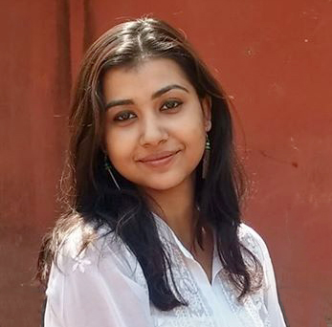ASmita bhattacharya  DOB : 19.02.1995  consultant  (larsen & toubro)  address  P-86-G C.I.T. ROAD, Entally First Floor, Kolkata: 700014  West Bengal  CONTACT  Phone: +91 -9830610869(Mobile)  bhattacharya.asmita192@gmail.com  www.linkedin.com/in/asmita-bhattacharya-835b5816b |  | WORK EXPERIENCE
- Worked in Larsen &Toubro, Vadodara as Geosciences’ Consultant and also as part of the Project Management Operations (June 2019 – June 2020).

Deliverables & Job Role

- Worked on data gathering and data maintenance with reference to geophysical and hydrocarbon data in company databases.
- Identified and documented detailed business rules.
- Updating and maintaining data quality.
- Performing quality checks & ensuring timely completion
Of existing workflow.
- Study of SOW’s & MSA.
- Monitoring & Analyzing of Planned & Actuals with respect to
Deadlines promised to Client.
- Preparing of Dashboards for high level view both for
Internal management & client end.

 |  | SKILLS, certificates & interests
COMPUTING SKILLS:

- MS Excel (Proficient in Pivot, Power Pivot, Charts, Analytics Pack etc.)
- BI Tools - Power BI & Tableau.
- PowerPoint – Well adept in High-Level PPT’s and wider audience.
- QGIS, ArcGIS, Perplex, AutoCAD

ANALYTICAL SKILLS

Predictive Analysis and Forecasting, Root Cause Analysis, Quality Analysis and KPI’s, Lean & Six Sigma Methodology Practitioner (DMAIC), Impact Analysis,
Value Stream Maps, Pareto Chart, Fish Bone / Ishikawa Analysis.

PROFESIONAL CERTIFICATIONS include Project Management,
Health, Safety and Environment Management (HSE) and SIX SIGMA.

INTERESTS include reading, painting, and map studying.

DECLARATION:

I hereby declare that the above information is correct to the best of my knowledge.

Place: Kolkata Asmita Bhattacharya

