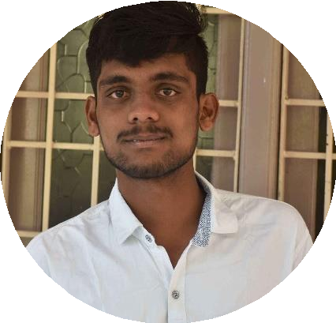

PERSONAL INFO

Address:

18-489, Tirumala Colony, Shadnagar, Rangareddy, Telangana- 509216.

**Phone:**

+91-9542165573

**Email:**

[Bharathmahi123@gmail.com](mailto:Bharathmahi123@gmail.com)

**Date of Birth:**

06-August-1998

SKILLS

Team Management Data Interpretation

Ability to work in any Environment Decision Making

Problem Solving

LANGUAGES

English Telugu Hindi

COMPUTER PROFICIENCY

AutoCAD 2D & 3D MS Excel StradPro

Geo Studio MATLAB

Geo-technical Engineer

*

NADIKUDA BHARATH

To work in an organization in a responsible position where my technical and management skills should be enhanced and implemented for the organization’s growth.

# EMPLOYMENT HISTORY

**Geo-technical Engineer | May 2022 – May 2023**

## KDM Engineers Pvt.Ltd, Hyderabad

**Geo-technical Engineer | June 2023 – till date**

## Maark civil Engineer Pvt.Ltd, Hyderabad

## Site Investigation on high-rise buildings and Gravity Dams. Playing an Executive

## role in collecting the samples from sites and conducting tests like direct shear

## tests on them.

# EDUCATION

## Masters in Technology | 2020 – 2022

**National Institute of Technology, Andhra Pradesh**

Geotechnical Engineering | CGPA: 7.2

## Bachelor of Technology | 2017-2020

**Siddhartha Institute of Engineering and Technology, Hyderabad**

Civil Engineering | CGPA: 6.67

## State Board of Technical Education and Training | 2014 – 2017 TKR Institute of Engineering and Technology, Hyderabad

Diploma | Civil Engineering | percentage: 73%

## Board of Secondary Education | 2014 Sri Satya Sai High School, Shadnagar

CGPA: 9.8

PROJECTS

## Estimation and Costing of Residential Building (Nov 2019 – Mar 2020)

Determining the cost of Building using software that will be helpful for the design of the building.

## Investigation on Thermal properties of soils amended by Agro based ashes by using Geo Studio (June 2021 – April 2022)

By using Geo Studio temp/w, future predictions of thermal properties and temperature can be known when soils are mixed with ashes.

CERTIFICATIONS

* Participated in an Integrated approach in association with EWB-TKREC
* Active participation in college cultural activities and sports events
* Participated in faculty development program on ‘**Advances in Environmental Geotechnics**’.