ǀ CURRICULUM VITAE ǀ
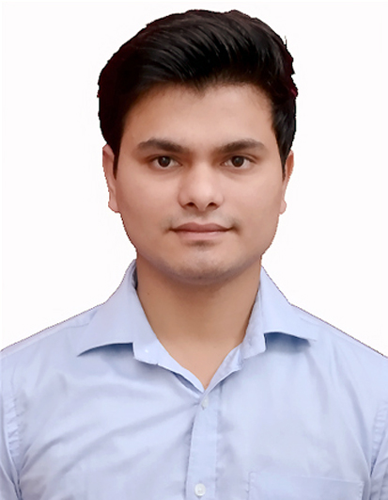

Amit Rautela
H. No. 231, Lohariyasal Talla,
Haldwani, District - Nainital
Uttarakhand - 263139
Email Id: amit.rautela74@yahoo.com
Phone No: +91-9646537344
CAREER OBJECTIVE:
To succeed in an environment of growth and excellence where I can sharpen my knowledge as well as acquire new skills and earn a job which provides me satisfaction and self-development which further help me to achieve organizational goals.
EDUCATIONAL QUALIFICATIONS:
DEGREE/ COURSE | INSTITUTION/ BOARD | YEAR | CGPA / PERCENTAGE
M. Tech. - (Structural Engineering) | G.B Pant University of Agriculture & Technology, Uttarakhand | 2018 | 7.264
B. Tech. (Hons) - Civil Engineering | Lovely Professional University, Punjab | 2016 | 8.33
12th | Army Public School (C.B.S.E), Maharashtra | 2012 | 84.60 %
10th | Army Public School (C.B.S.E), Maharashtra | 2010 | 9.2

TECHNICAL SKILLS: PERSONAL SKILLS:
Software: Auto Cad 2D, Staad-Pro, MS-Word, Excel, Power point Effective communication and interpersonal skills Languages: basics of C and C++ Team player and Leadership skills
DBMS: Oracle 8i Quick learner and responsible towards work
INTERNSHIP:
Organization: Adani M2K Projects LLP. From June – July, 2015 and From January – June, 2016
Description : Worked as a trainee in project “Oyster Grande”, Sector – 102, Gurgaon. Project Value – INR 250 Crs
Worked in Execution Department, Quality Control Department, Quantity Surveying Department and
Planning Department at site.
Responsibilities:
- Learnt and assisted construction in-charge in executing the works as per specifications and schedule.
- Learnt and assisted in preparing BBS.
- Learnt and assisted in conducting various experimental Lab tests.
- Learnt and assisted in making monthly, weakly and daily plan to achieve the targets.
PROJECTS/ THESIS:
Thesis: Numerical Modelling for Square CFST Column Filled with Normal Strength Concrete under Axial Compression. Objective: To compare and validate the predicted results of load vs axial strain of square shaped CFST column with the previous experimental results.
Description: An equation was developed using regression analysis for axial load vs strain curve of a square - shaped CFST column in order to compare and validate the predicted results with the previous experimental results. Also, an extensive numerical parametric study was conducted to analyze the effect of various parameters on the behavior of the square - shaped CFST column.
Project: To study the wettability and surface tension of water.
Objective: To reduce the surface tension of water with the help of electric current.
Description: Electric circuit was formed with the needle and touched with drop of water as a result shape of drop got flattened i.e. Surface tension got reduced and this water can be used for various purpose like washing of clothes without detergent and for fine spray of paint or pesticide.
WORKSHOPS / CERTIFICATIONS/ SEMINARS:
- Organized and Participated in All India Seminar on “ADVANCES IN TECHNOLOGY TO MITIGATE THE EFFECT OF NATURAL HAZARDS” by - The Institution of Engineers, held at GBPUA&T in March 2017.
- Organized and Participated in a workshop on “BRIDGE DESIGNING” by Civil Simplified – An IIT Kanpur incubated Company, held at Lovely Professional University in March 2014.
- Organized and Participated in a workshop – “CADD-EX” on Autodesk Revit and MSP, held at Lovely Professional University in September 2013.
- Participated in 2 days workshop on “ETHICAL HACKING” Organized by Wegilant Net Solutions Pvt Ltd. – An IIT Bombay incubated Company, held at Lovely Professional University in August 2012.
CO-CURRICULAR ACTIVITIES:
- Event In-charge, Aavirbhav-2014, Annual Student Organization Tier Evaluation Ceremony, 2014.
- Organized numerous events at University Level in 2012, 2013 and 2014.
- Organized Civil Engineering Fest “AARAMBH-2013 and 2014”, held at LPU.
- Participated in “YOUTH VIBE-2013” (National Level Fest) and “YOUTH VIBE-2014” (Global Level Fest), held at Lovely Professional University.
- Participated in Intra University Debate Competition, April 2013.
- Organized and Participated in 3rd BHARTIYA VIGYAAN SAMMELAN AND EXPO 2012, held at Lovely Professional University in October 2012.
- Member of Event Report Compiling Team, ICARUS-SO Fest, Lovely Professional University, 2012.
- Participated in Various intra school competitions like Quizzes, Singing, Basketball-Zonal Level, other Sports and Cultural Events and bagged many awards for the same.
AWARDS AND HONOURS:
- Qualified GATE (Graduate Aptitude Test for Engineers) Exam in first attempt in 2016.
- Secured 3rd Position in LPU’s Annual Mega Cultural Event – “ONE WORLD” collaborated with AIU’s 7th SAUFEST (South Asian Universities Festival), 11th March 2014 to 15th March 2014.
- Secured 3rd Position in LPU’s Annual Mega Cultural Event – “ONE INDIA”, 18th February 2014 to 19th February 2014.
- Secured 2nd Position in Inter University Singing Competition, held at LPU in September 2013.
- Secured 1st Position in Inter School Basketball Championship, 2011.
- Secured 2nd Position in Inter House Quiz competition in School, 2008.
RESPONSIBILITIES HELD:
- Student Placement Coordinator, 2015-2016
- Class Representative, 2013-2014
- Database Manager in the Student Organization – THE BRIDGE, 2013-2014
- Event Coordinator in the Student Organization – THE BRIDGE, 2012-2013
HOBBIES/ INTEREST:
Exploring new places, singing, playing outdoor games, swimming and watching historical and knowledgeable things.
PERSONAL DETAILS:
Mother’s Name: Mrs Geeta Rautela
Father’s Name: Mr Kripal Singh Rautela
Date of Birth: 10th September 1993
Gender: Male
Languages Known: English, Hindi.

DATE:

PLACE: AMIT RAUTELA

